Procfs and Sysfs

What is Procfs?

Procfs or "/proc" is a special filesystem under Linux that is used to present process information and kernel processes. Although "/proc" is still used widely, much of the information found on systems running with a kernel level of 2.6 and above have been moved to another pseudo filesystem called "sysfs" which is generally mounted under "/sys". "/proc" is stored in memory, unlike other filesystems, which are stored on disk. If you list the "/proc" filesystem, you will notice that the majority of files are of a "0" byte length. However, if you view the contents of the file, you will see that there is quite a substantial amount of information within. The numbers represent a process (PID - Process ID). Each of these numbers is a directory. Within each of these numbered directories are further files that contain information about the running process.

Important Directories to know

At times it useful to know where to find information about your system quickly. You may wish to find memory information or information regarding your CPUs present on your system. This information can be found under "/proc". Many utilities and programs will read the information contained in many of these directory structures and report this back to your screen.  
Below is a list of some of most useful to know directories:

**/proc/fb** : List of available frame buffers  
**/proc/cpuinfo** : Lists information about your systems CPU - Family, vendor information, Model number, Core Speeds and CPU flag information.  
**/proc/devices** : Contains a list of character and block devices  
**/proc/diskstats** : Lists information relating to Logical Disk Devices  
**/proc/filesystems** : List of filesystems that are supported by the kernel  
**/proc/interrupts** : Interrupt information can be found here  
**/proc/iomem** : Contains a map of the systems memory for each physical device  
**/proc/ioports** : Contains a list of currently registered port regions used for input or output communication with a device.  
**/proc/irq :** This directory contains directories that correspond to IRQs present on your system. SMP affinity information may be modified here.  
**/proc/meminfo** : Contains kernel memory information  
**/proc/modules** : Contains currently loaded modules within the kernel. "lsmod" command obtains its information from here  
**/proc/mounts** : Contains information regarding mounts. Filesystems in use and what mount options are in use are also listed  
**/proc/net** : Network stack information  
**/proc/partitions** : A list of the device numbers, their size and their /dev names which the kernel has identified as a partition  
**/proc/slabinfo** : Contains kernel slab statistics  
**/proc/swaps** : List of active swap partitions and their size  
**/proc/sys** : Dynamically configurable kernel options can be found here  
**/proc/uptime :** The amount of time in seconds the kernel has been running since boot time and spent in idle mode.  
**/proc/version** : Contains kernel information, version number, gcc version number used for building the kernel

What is sysfs?

Many newer distributions of Linux are using "sysfs" mounted on /sys as a way of exporting information from the kernel to various applications. "sysfs" generally contains nine top level directories:

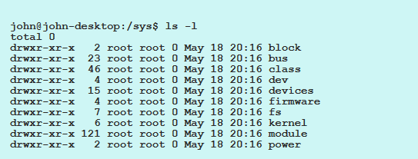

Brief explanation of directories within "/sys"

**/sys/block** : Contains known block devices  
**/sys/bus :** Contains all registered buses.  
**/sys/class** : Contains Devices  
**/sys/device :** All devices known by the kernel organised by the bus that they connect to  
**/sys/firmware :** Contains firmware files for some devices  
**/sys/fs** : Contains files to control filesystems  
**/sys/kernel** : Various kernel related files  
**/sys/module** : Loaded kernel modules. Each module is represented by a directory of the same name.  
**/sys/power** : Various files to handle power state of system